Họ tên : Lê Bảo Khánh

MSSV : 1911363

Lớp : L01

**LAB 2a**

**1. The Basic HTTP GET/response interaction**

**Question 1**: Is your browser running HTTP version 1.0 or 1.1? What version of HTTP is the server running?

**ANSWER:**

HTTP version 1.1 for both

**Question 2:** What languages (if any) does your browser indicate that it can accept to the server?

**ANSWER:**

Accept-Language: en-US,en;q=0.9\r\n

**Question 3:** What is the IP address of your computer? Of the gaia.cs.umass.edu server?

**ANSWER:**

IP address of my computer: 192.168.1.12

IP address of gaia.cs.umass.edu server: 128.119.245.12

**Question 4:** What is the status code returned from the server to your browser?

**ANSWER:**

200

**Question 5:** When was the HTML file that you are retrieving last modified at the server?

**ANSWER:**

Last-Modified: Mon, 11 Oct 2021 05:59:02 GMT

**Question 6:** How many bytes of content are being returned to your browser?

**ANSWER:**

Content-Length: 128

**Question 7:** By inspecting the raw data in the packet content window, do you see any headers within the data that are not displayed in the packet-listing window? If so, name one.

**ANSWER:**

No, I do not see any headers displayed

**Output Annotation:**

**\*\*\*\*\*GET message\*\*\*\*\***

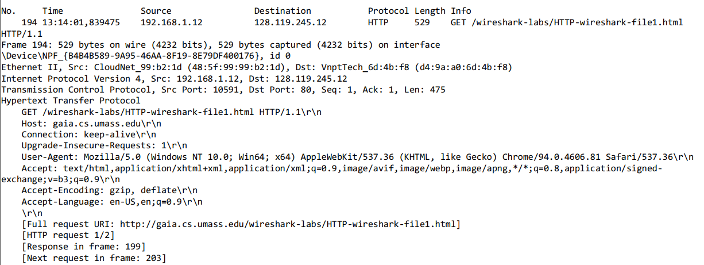

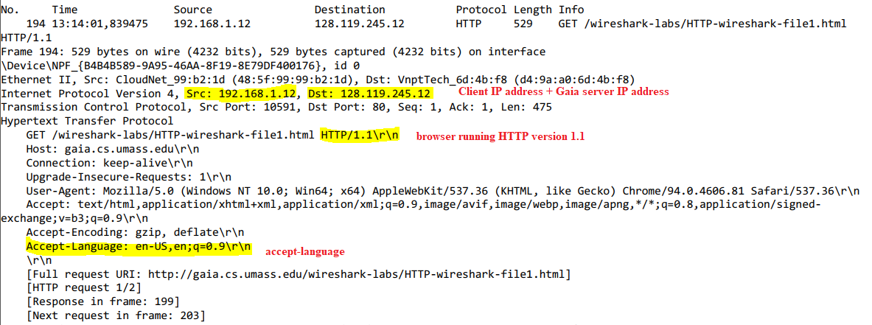

**\*\*\*\*\*Response message\*\*\*\*\***

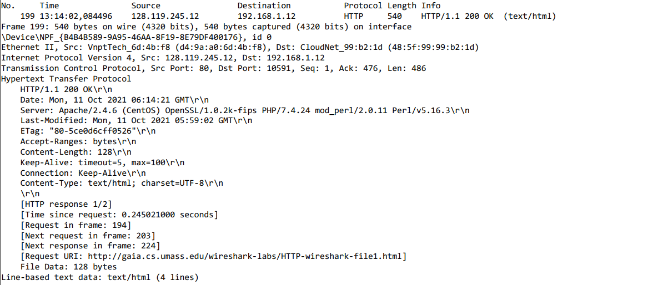

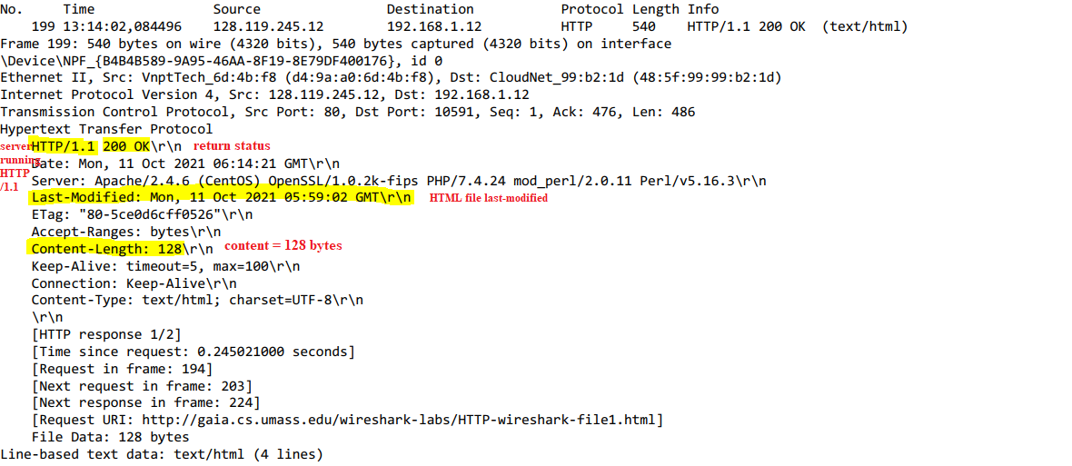

**2. The HTTP CONDITIONAL GET/response interaction**

**Question 8**: Inspect the contents of the first HTTP GET request from your browser to the server. Do you see an “IF-MODIFIED-SINCE” line in the HTTP GET?

**ANSWER:**

No, I do not see “IF-MODIFIED-SINCE” line in the 1st HTTP GET

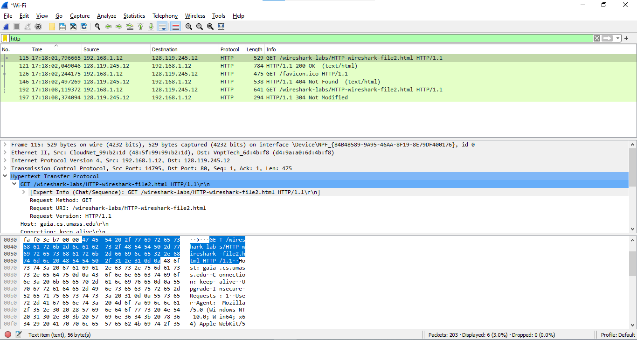

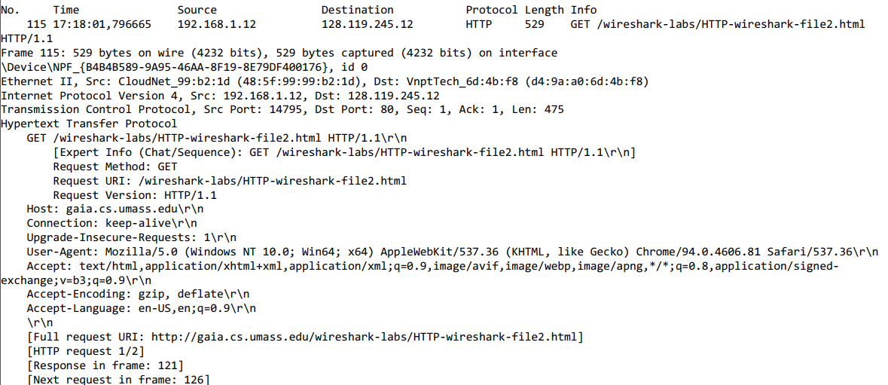

**Question 9:** Inspect the contents of the server response. Did the server explicitly return the contents of the file? How can you tell?

**ANSWER:**

Yes because we can see the contents in the line-based text data field.

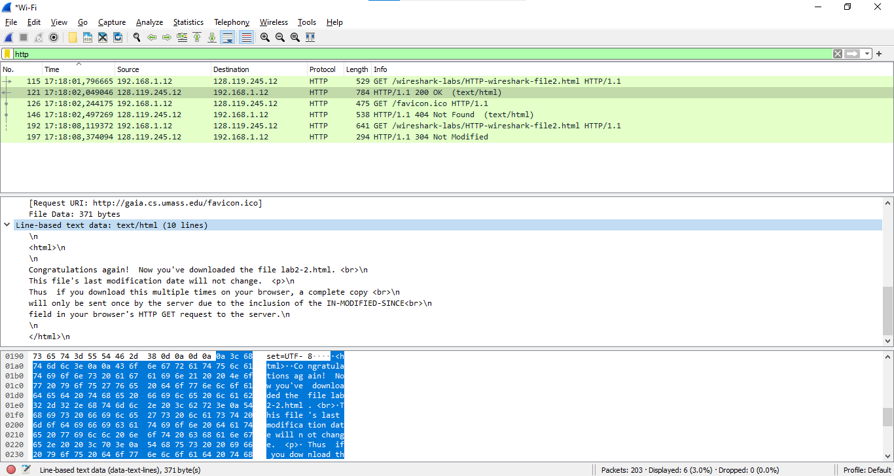

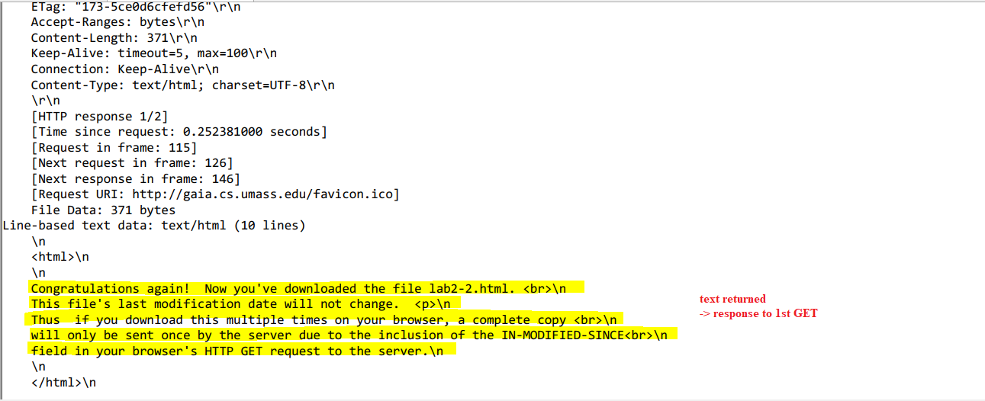

**Question 10:** Now inspect the contents of the second HTTP GET request from your browser to the server. Do you see an “IF-MODIFIED-SINCE:” line in the HTTP GET? If so, what information follows the “IF-MODIFIED-SINCE:” header?

**ANSWER:**

Yes, I see.

In the 2nd HTTP message, an IF-MODIFIED-SINCE line is included, followed by the date and time that I last accessed to this webpage

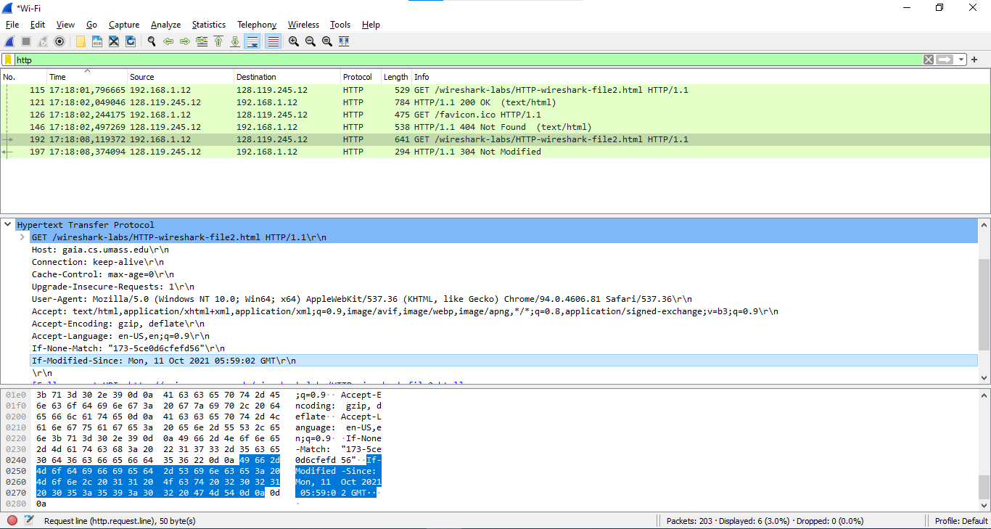

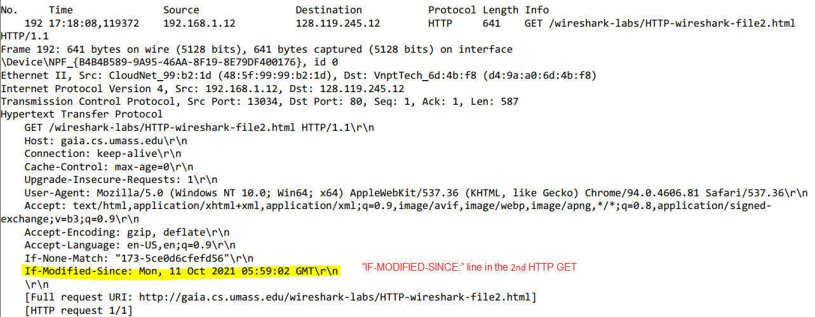

**Question 11:** What is the HTTP status code and phrase returned from the server in response to this second HTTP GET? Did the server explicitly return the contents of the file? Explain.

**ANSWER:**

The HTTP status code is “304: Not Modified”

The server did not return the contents of the file because the browser simply retrieved the contents from its cache. If the file had been modified since last access, it would have returned the contents of the file, instead it simply told the browser to retrieve the old file from its cached memory.

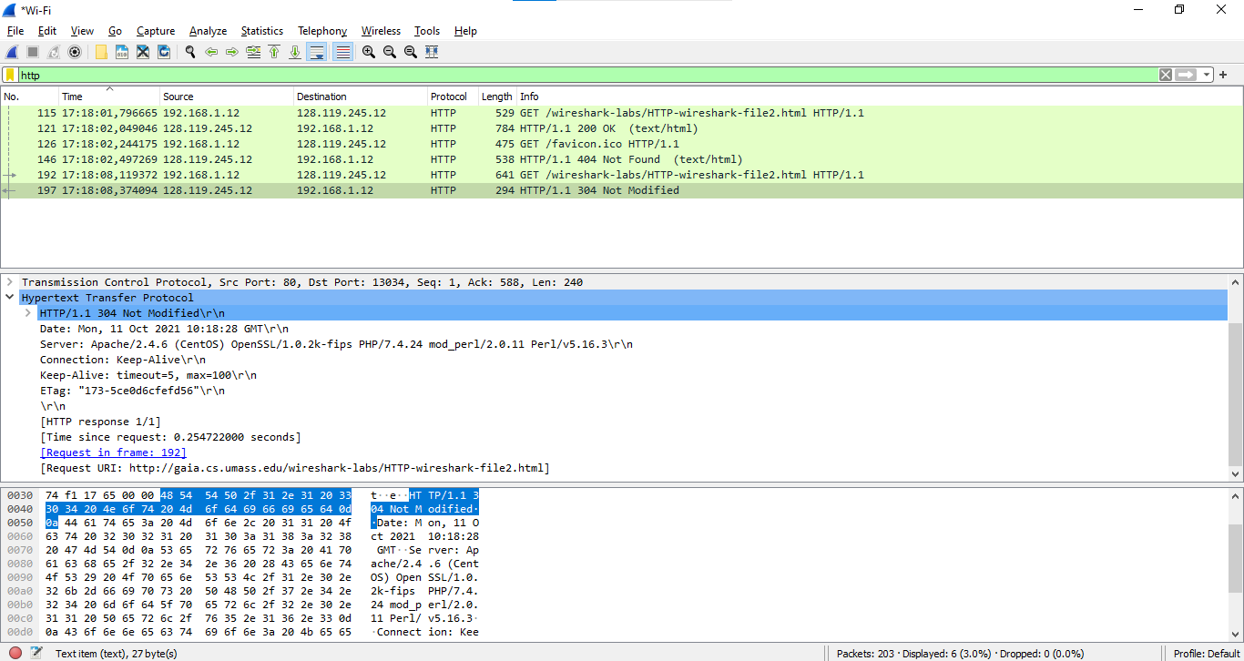

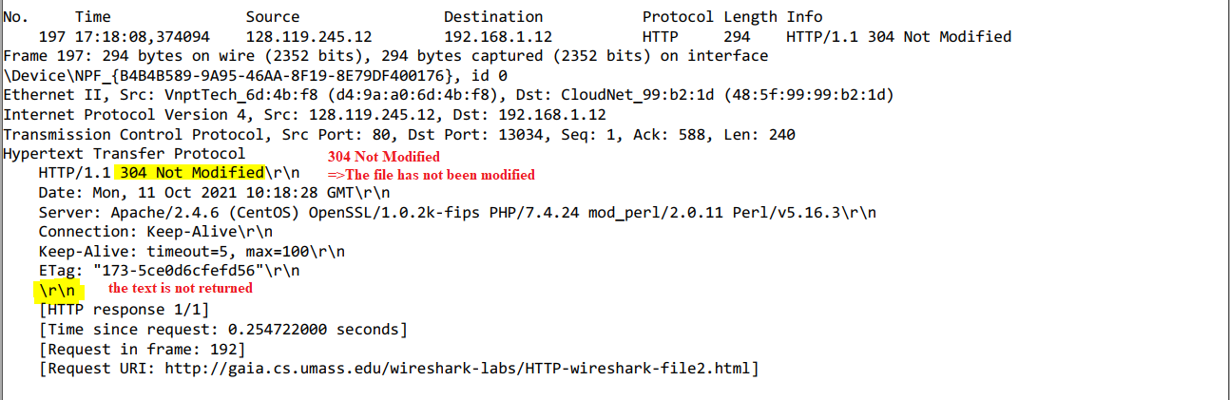

**3. Retrieving Long Documents**

**Question 12**: How many HTTP GET request messages did your browser send? Which packet number in the trace contains the GET message for the Bill or Rights?

**ANSWER:**

There is 1 HTTP GET request

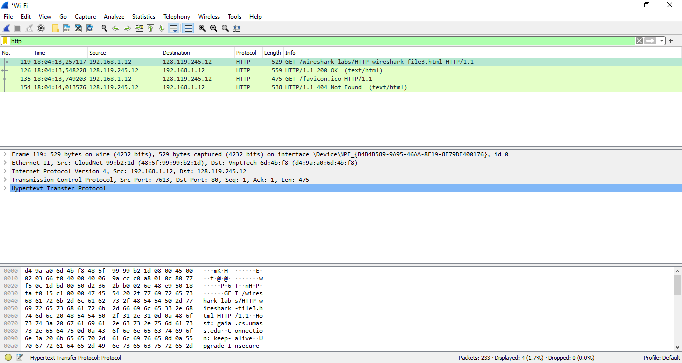

Packet number in the trace contains the GET message for the Bill or Rights: 119

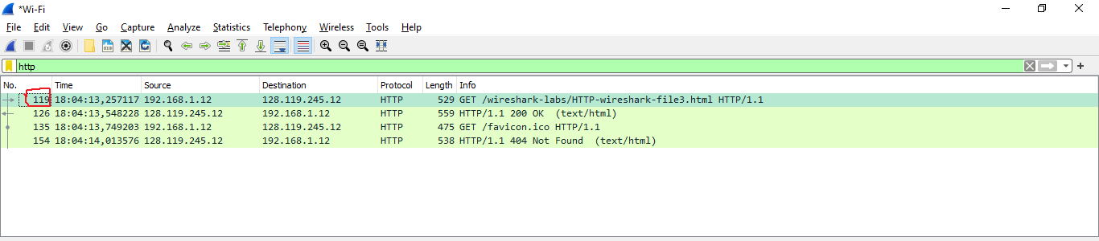

**Question 13** Which packet number in the trace contains the status code and phrase associated with the response to the HTTP GET request?

**ANSWER:**

Packet number in the trace contains the GET message for the Bill or Rights: 126

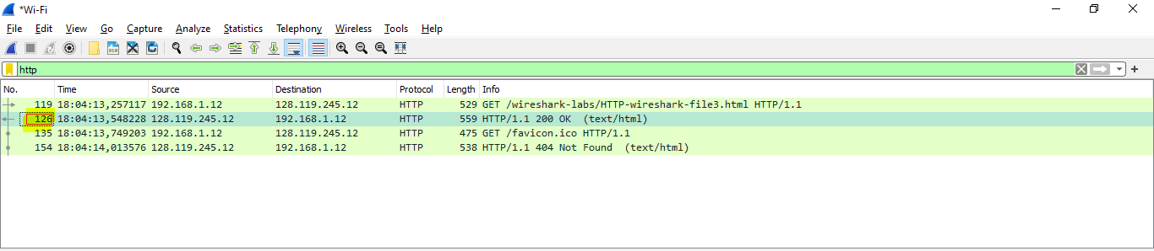

**Question 14:** What is the status code and phrase in the response?

**ANSWER:**

200 OK

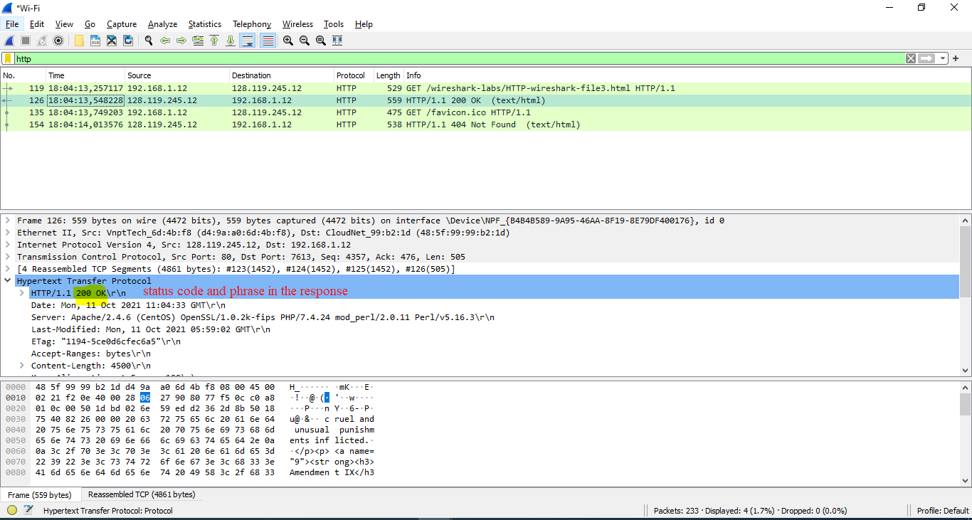

**Question 15:** How many data-containing TCP segments were needed to carry the single HTTP response and the text of the Bill of Rights?

**ANSWER:**

4 data-containing TCP segments

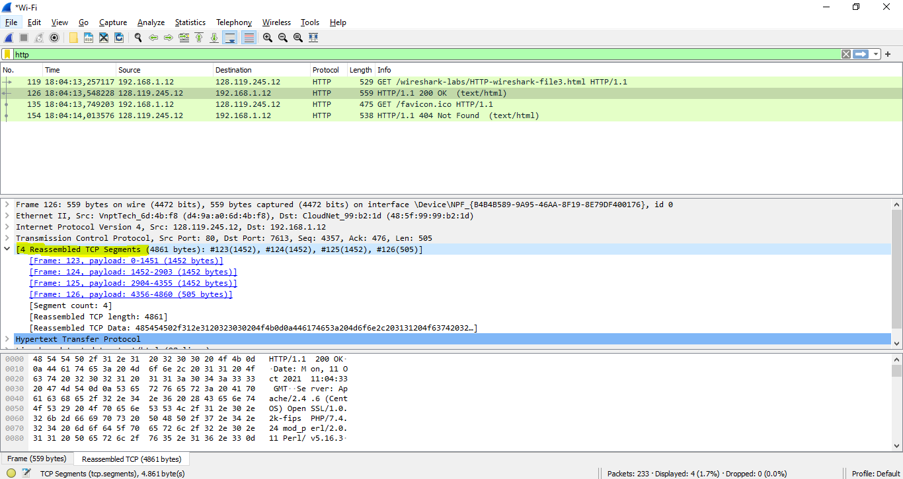

**4. HTML Documents with Embedded Objects**

**Question 16:** How many HTTP GET request messages did your browser send? To which Internet addresses were these GET requests sent?

**ANSWER:**

There were 3 HTTP GET requests sent to the following Internet addresses:

128.119.245.12, 128.119.245.12, 178.79.137.164

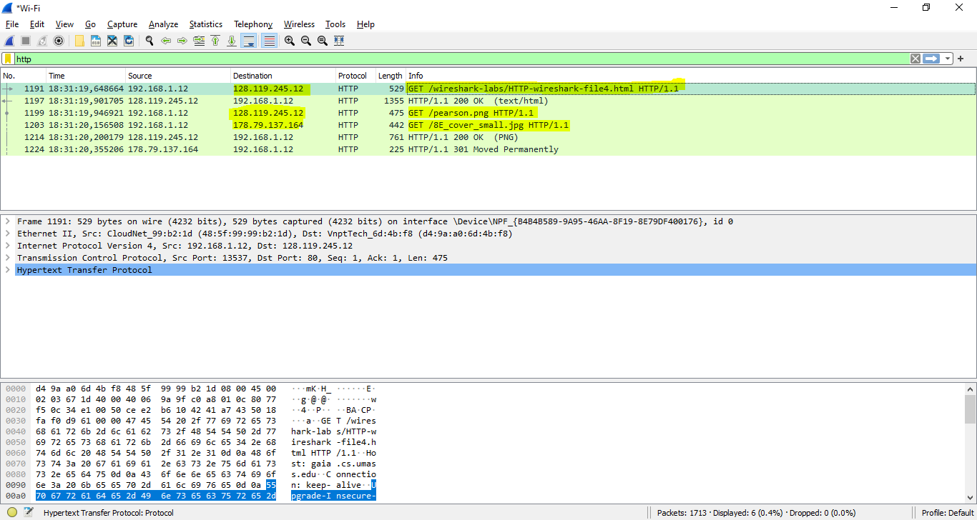

**Question 17:** Can you tell whether your browser downloaded the two images serially, or whether they were downloaded from the two web sites in parallel? Explain.

**ANSWER:**

The downloads occurred in parallel:

+ The 2 GET messages for the images are in packets 1199 and 1203.

+ The response for these messages are in packets 1214, and 1224.

Thus the request for the 2nd image file (packet 1203) was made **BEFORE** packet 1214, the first image file was received.

=> The downloads occurred in parallel

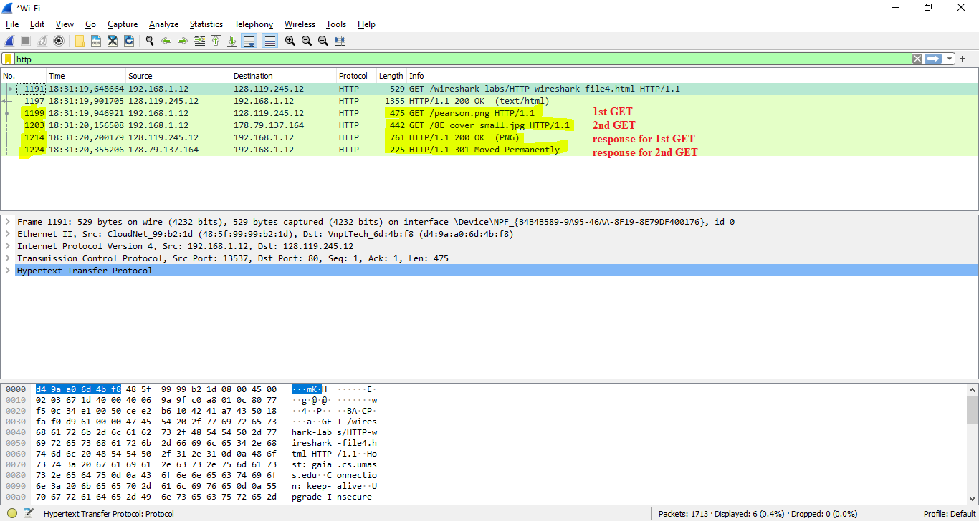

**5 HTTP Authentication**

**Question 18:** What is the server’s response (status code and phrase) in response to the initial HTTP GET message from your browser?

**ANSWER:**

Initial HTTP GET response: 401 Unauthorized

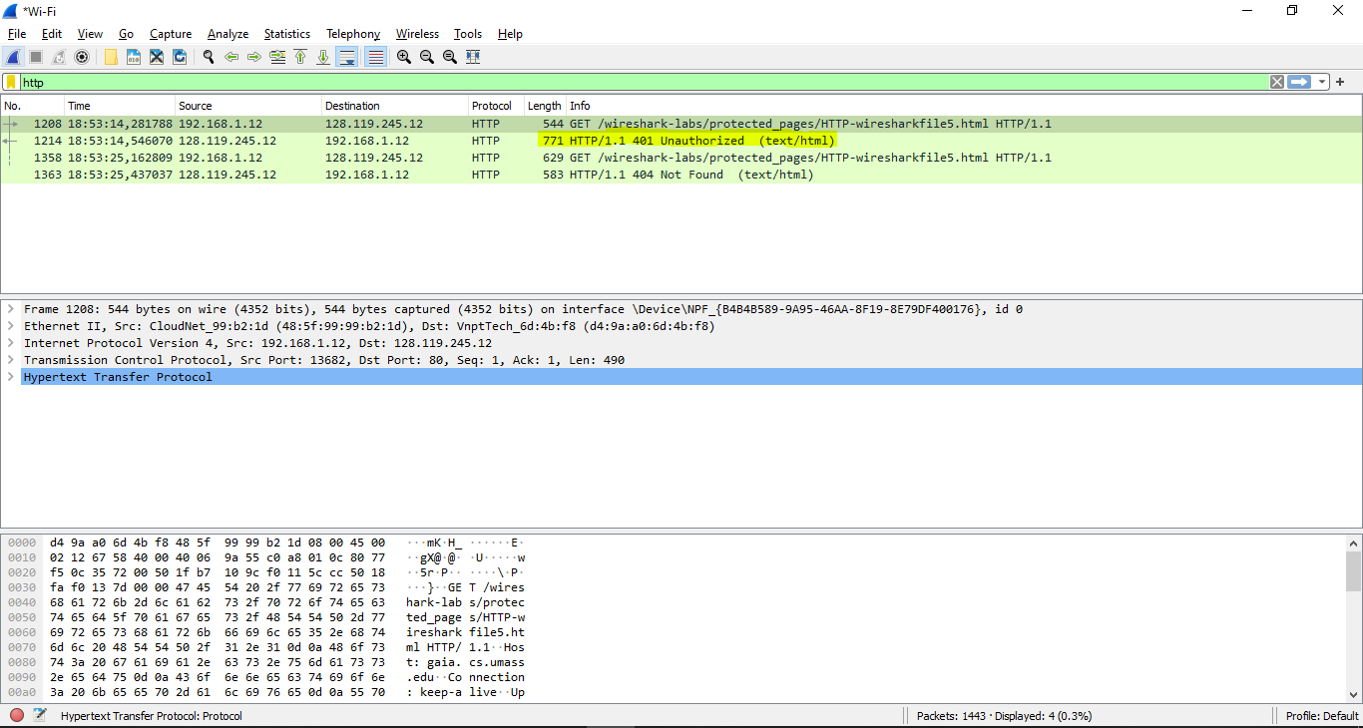

**Question 19:** When your browser’s sends the HTTP GET message for the second time, what new field is included in the HTTP GET message?

**ANSWER:**

The HTTP GET includes the Authorization: Basic: field

